Week4
- Segmentation concepts
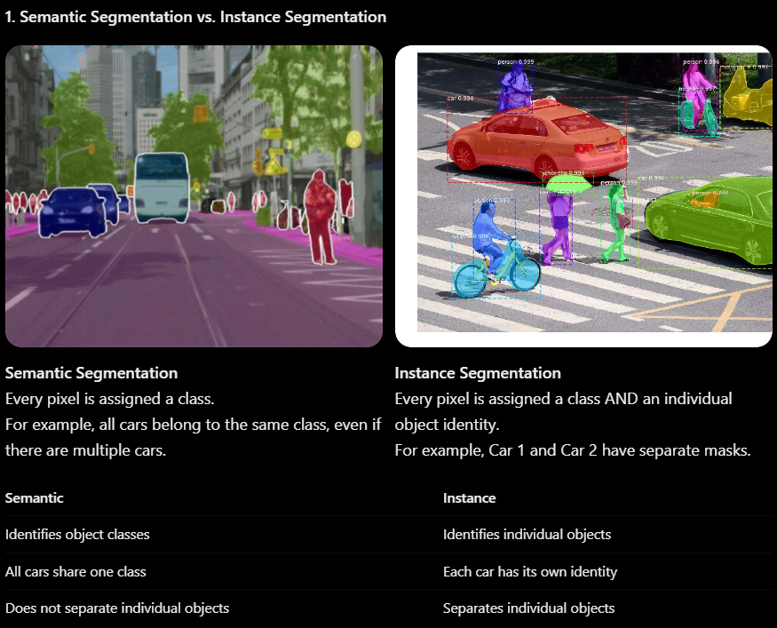
· Semantic = What is this pixel?
· Instance = What is this pixel, and which object does it belong to?
Encoder-Decoder Architecture
has two main parts:
A. Encoder (Contracting Path)
Its job is to understand the image.
Takes the original image.
Applies convolution layers to extract features.
Uses pooling to reduce image dimensions.
Learns high-level information about objects.
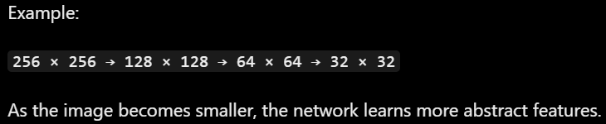
B. Decoder (Expanding Path)
Its job is to reconstruct the segmentation map.
Increases spatial dimensions.
Recovers the image's spatial details.
Produces a pixel-level prediction.
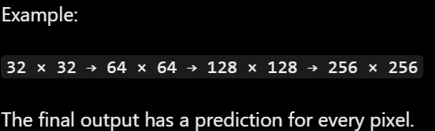

- Net Architecture
U-Net is a CNN architecture designed for image segmentation.
It gets its name from its U-shaped structure.
How does it work?
It consists of three important concepts:
Contracting path (Encoder) Extracts important features from the input image while gradually reducing its spatial dimensions through convolution and pooling layers.
Expanding path (Decoder) Gradually increases the spatial dimensions to reconstruct the image and generate a pixel-level segmentation map.
Skip connections Transfer feature maps from the encoder to the decoder at corresponding levels, preserving fine details and spatial information lost during downsampling.
Why do we need skip connections?
When the encoder repeatedly applies pooling, some spatial details can be lost.
Segmentation Loss Functions
Loss functions measure how different the predicted segmentation mask is from the actual mask (ground truth).
You need to understand three types:
A. Pixel-wise Cross Entropy Loss
Compares the predicted class with the actual class for every pixel.
Penalizes incorrect pixel classifications.
Commonly used for multi-class segmentation.
Example: If a pixel actually belongs to the road class but the model predicts car, the loss increases.
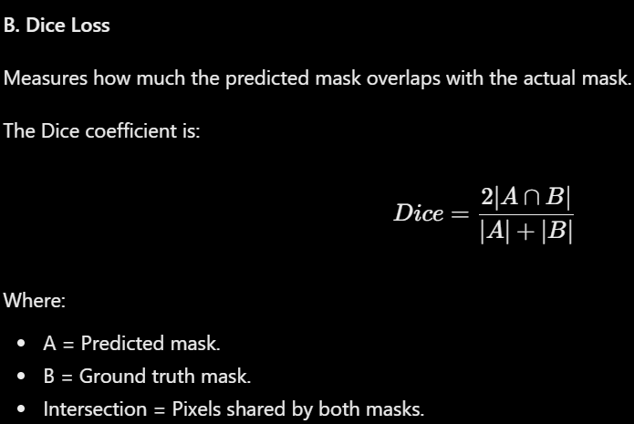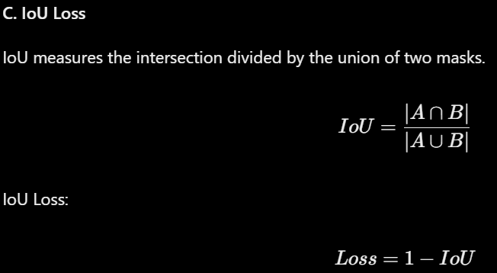



Segmentation Evaluation Metrics
how to evaluate a segmentation model.
Metric | Meaning
Pixel Accuracy | Percentage of correctly classified pixels
Mean IoU | Average IoU across all classes
Dice Score | Overlap between predicted and actual masks
Important difference:
Pixel Accuracy can sometimes be misleading.
Imagine an image where:
90% of pixels represent background.
10% represent a tumor.
A model that predicts everything as background could achieve 90% pixel accuracy while completely failing to detect the tumor.
That's why Mean IoU and Dice are useful, especially when classes are imbalanced.
1. How is image segmentation different from image classification and object detection?
The main difference is the level of detail each task provides:
Image Classification: Identifies what objects or classes are present in an image without locating them.
Object Detection: Identifies objects and locates them using bounding boxes.
Image Segmentation: Classifies individual pixels to identify the exact shape and boundaries of objects in an image.
Classification = What is in the image?
Detection = What is in the image and where is it?
Segmentation = Which exact pixels belong to each object?
- Train a segmentation model
- Compare the metrics
- Error analysis

- Vision Transformers: intuition only
How does a CNN treat an image?
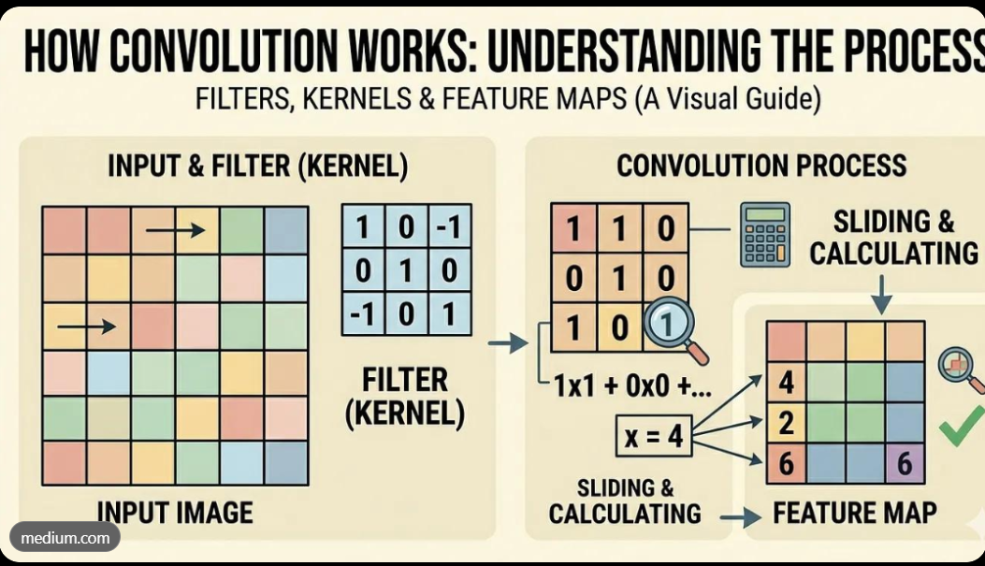
A CNN processes an image using convolutional layers.
For example, when you give a CNN an image of a cat:
Early layers detect simple features such as edges and colors.
Deeper layers combine these features to recognize shapes and patterns.
Later layers learn more complex features, such as eyes, ears, and faces.
The model uses these features to make a prediction.
Important: CNNs naturally focus on local regions through convolutional filters.
How does a Vision Transformer treat an image?
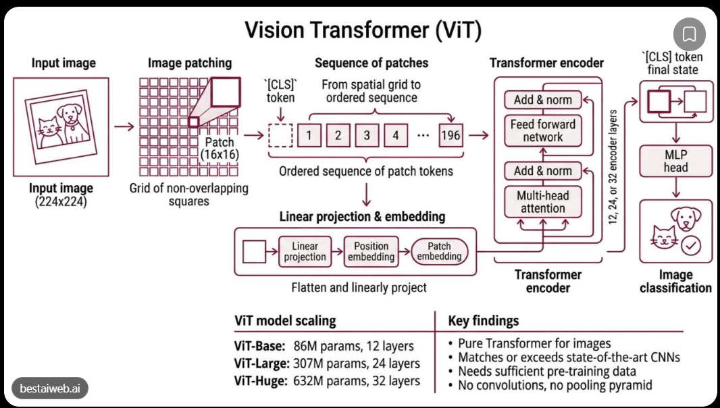
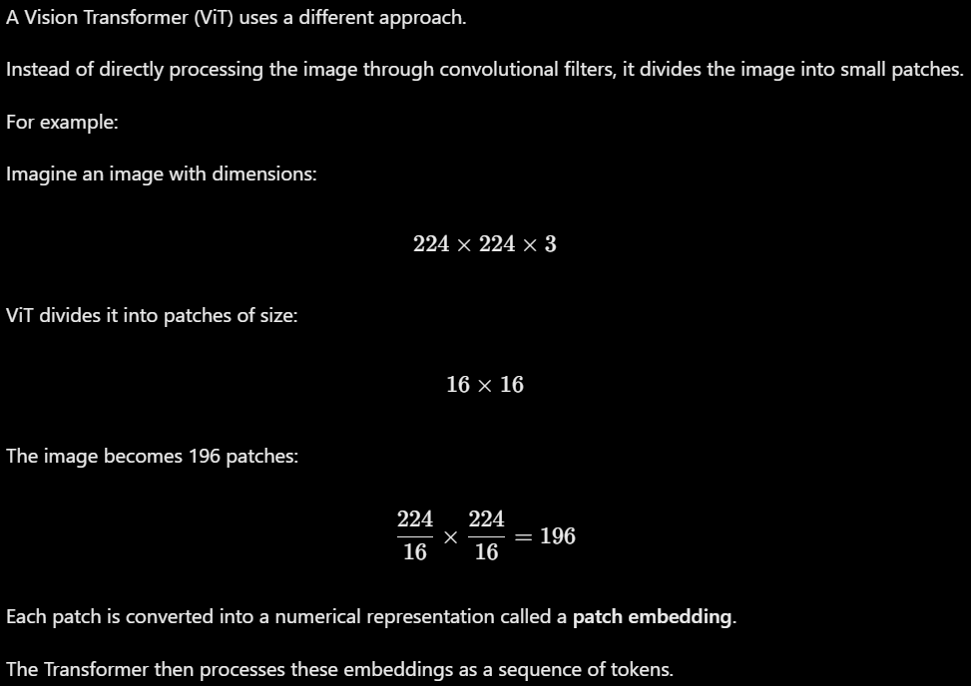
How does ViT understand relationships between patches?
This is where Self-Attention comes in.
Imagine an image containing a cat.
One patch contains the cat's eye.
Another patch contains its ear.
Another patch contains its body.
Self-attention allows the model to learn relationships between different patches, even when they are far apart.
Unlike a traditional CNN, which builds larger receptive fields through successive convolutional layers, ViT can directly model relationships between patches using attention.
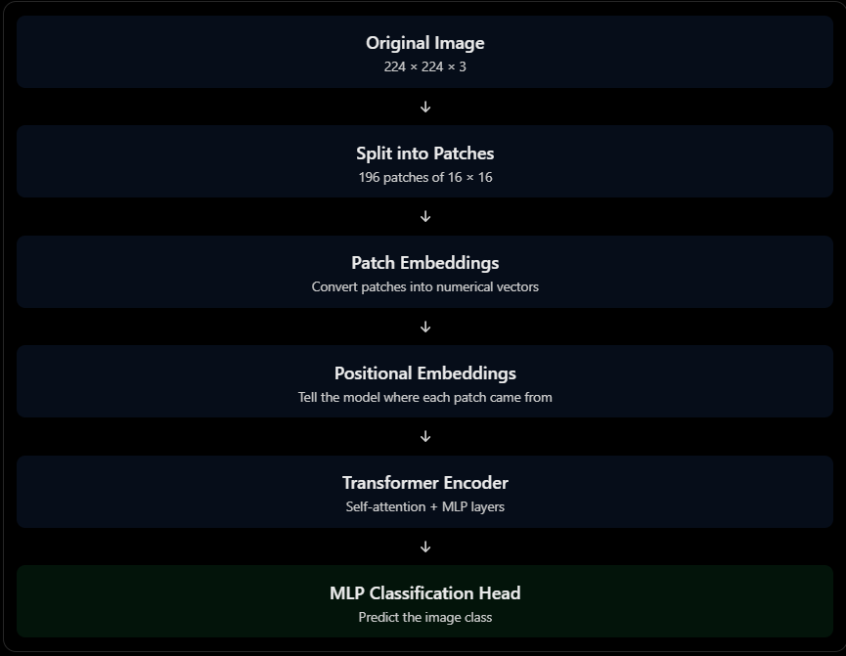

5. CNN vs. Vision Transformer
CNN | Vision Transformer
Uses convolution filters | Uses self-attention
Processes local regions | Can relate distant patches directly
Extracts features through convolution layers | Processes patch embeddings
Has built-in spatial inductive biases | Learns spatial relationships through attention and positional information

How does ViT treat an image differently from a CNN?
A CNN processes an image using convolutional filters that extract local features such as edges, shapes, and patterns through multiple layers.
In contrast, Vision Transformer divides an image into fixed-size patches, converts them into numerical embeddings, and feeds them into a Transformer encoder as a sequence of tokens.
Using self-attention, ViT learns relationships between different image patches, allowing it to capture global information across the image.
A CNN sees an image through convolutional filters, while ViT treats an image as a sequence of patches, similar to how NLP Transformers treat sentences as sequences of words.

- Computer vision wrap up note
Over the past four weeks, we have moved from answering “What is in this image?” to “Which exact pixels belong to each object?” This progression is not just about adding more outputs; it represents a fundamental shift in how we architect networks and conceptualize the relationship between spatial information and semantic meaning. Resala mo2asera
Classification (Week 1–2): We began with CNNs, which replaced fully connected networks to solve the parameter explosion and lack of spatial awareness.
By using parameter sharing and local connectivity, CNNs extract hierarchical features (edges → textures → objects).
Architecturally, the network ends with a global pooling or flattening operation, destroying spatial information to output a single class vector. Conceptually, the image is treated as a whole, and the model learns translation-invariant features (a cat is a cat regardless of position). Batch normalization and residual connections were introduced not to change the task, but to make training these deep feature extractors stable and feasible.
Object Detection (Week 3): Here,the question became “What and where?” Architecturally, we kept the CNN backbone but added a detection head that outputs bounding boxes and class scores. We moved from single-label outputs to multiple predictions per image, introducing concepts like anchor boxes (predefined shapes) and Non-Maximum Suppression (NMS) to resolve overlapping predictions. Conceptually, the network now has to regress spatial coordinates (localization) while classifying. The loss function changes to combine classification and localization errors, and evaluation shifts from accuracy to mAP, which penalizes poor box placement via IoU. Unlike classification, spatial information is no longer destroyed; it is refined into discrete regions.
Segmentation (Week 4): The question became “Which exact pixels belong to each object?” Architecturally, we abandoned the flattening/dense layers entirely. Instead, we use an encoder-decoder structure (like U-Net): the encoder downsamples to extract semantic features, while the decoder upsamples to recover spatial resolution. Skip connections are critical here—they transfer high-resolution details from encoder to decoder, compensating for the information lost during pooling. Conceptually, the output is no longer a vector or a set of boxes, but a dense, per-pixel classification map. The network must maintain spatial correspondence throughout, and loss functions shift to pixel-wise cross-entropy or Dice loss, which measure overlap rather than just classification correctness.
Summary: Classification taught us to extract what; detection taught us to localize where; segmentation taught us to delineate which pixels. Each step required us to preserve more spatial information, moving from global pooling to regional regression to dense, pixel-level prediction. The architectural evolution—from simple CNNs to detection heads to encoder-decoder skip connections—reflects a growing understanding that in vision, semantics and spatial structure are inseparable.

